**Steps for creating Micro-App Template**

1. **Windows**

* Navigate to Android studio installed path
* Navigate to templates folder through plugins 🡪 android 🡪 lib 🡪 templates
* Tap on activities folder and copy PhilipsMicroApp folder
* Tap on gradle-projects 🡪 NewAndroidProject 🡪 root 🡪 build.gradle
* Open build.gradle and copy artifactory repository urls, find the build.gradle.ftl shared for your reference.
* Restart android studio and select PhilipsMicroApp either as new project or new Module
* As App-infra and u-App are direct dependencies required to compile, versions of it are hardcoded in PhilipsMicroApp 🡪 recipe.xml.ftl, to update versions in future , we can open the file and update it.

1. **Mac**

* Navigate to Applications from Finder
* Right click on Android Studio and tap show package contents
* Navigate to templates folder through Contents 🡪 plugins 🡪 android 🡪 lib 🡪 templates
* Tap on activities folder and copy PhilipsMicroApp folder
* Tap on gradle-projects 🡪 NewAndroidProject 🡪 root 🡪 build.gradle.ftl
* Open build.gradle.ftl and copy artifactory repository urls, find the build.gradle.ftl shared for your reference.
* Restart android studio and select PhilipsMicroApp either as new project or new Module
* As App-infra and u-App are direct dependencies required to compile, versions of it are hardcoded in PhilipsMicroApp 🡪 recipe.xml.ftl, to update versions in future , we can open the file and update it.

**Steps in Selecting Philips Micro-app in Android Studio**

1. Create new project as show below

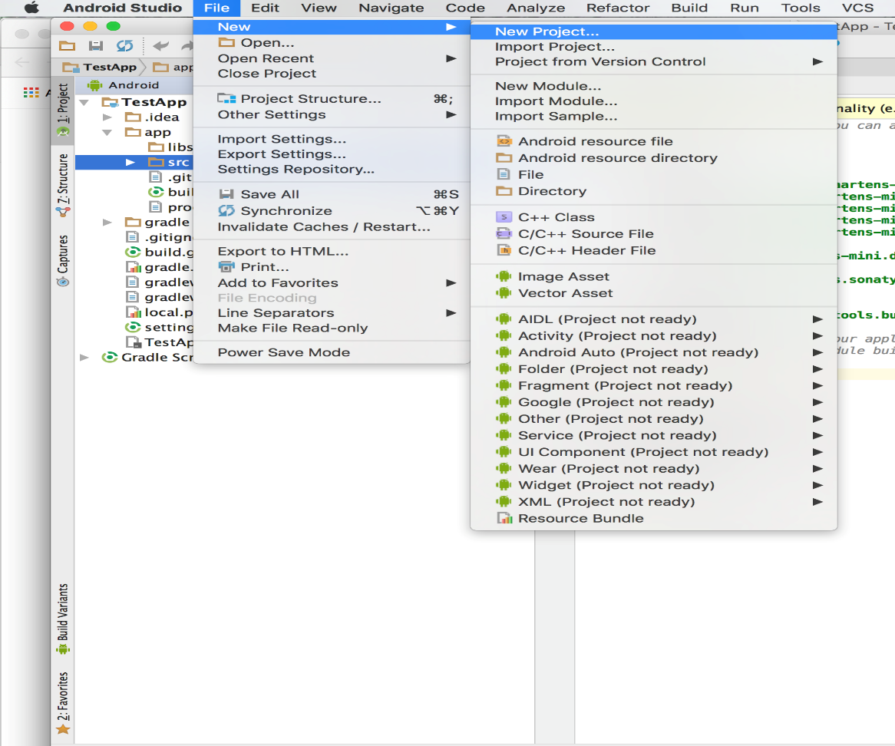

1. Provide Application name without space, as it concats app_name to uApp dependencies java files as shown below

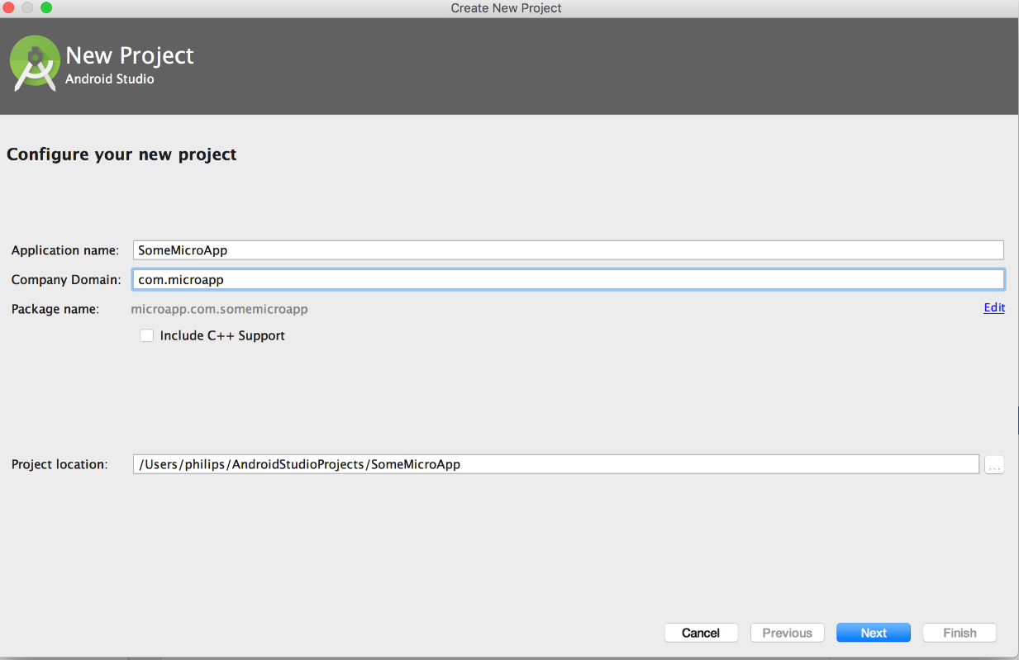

1. Select Philips uApp module as shown below

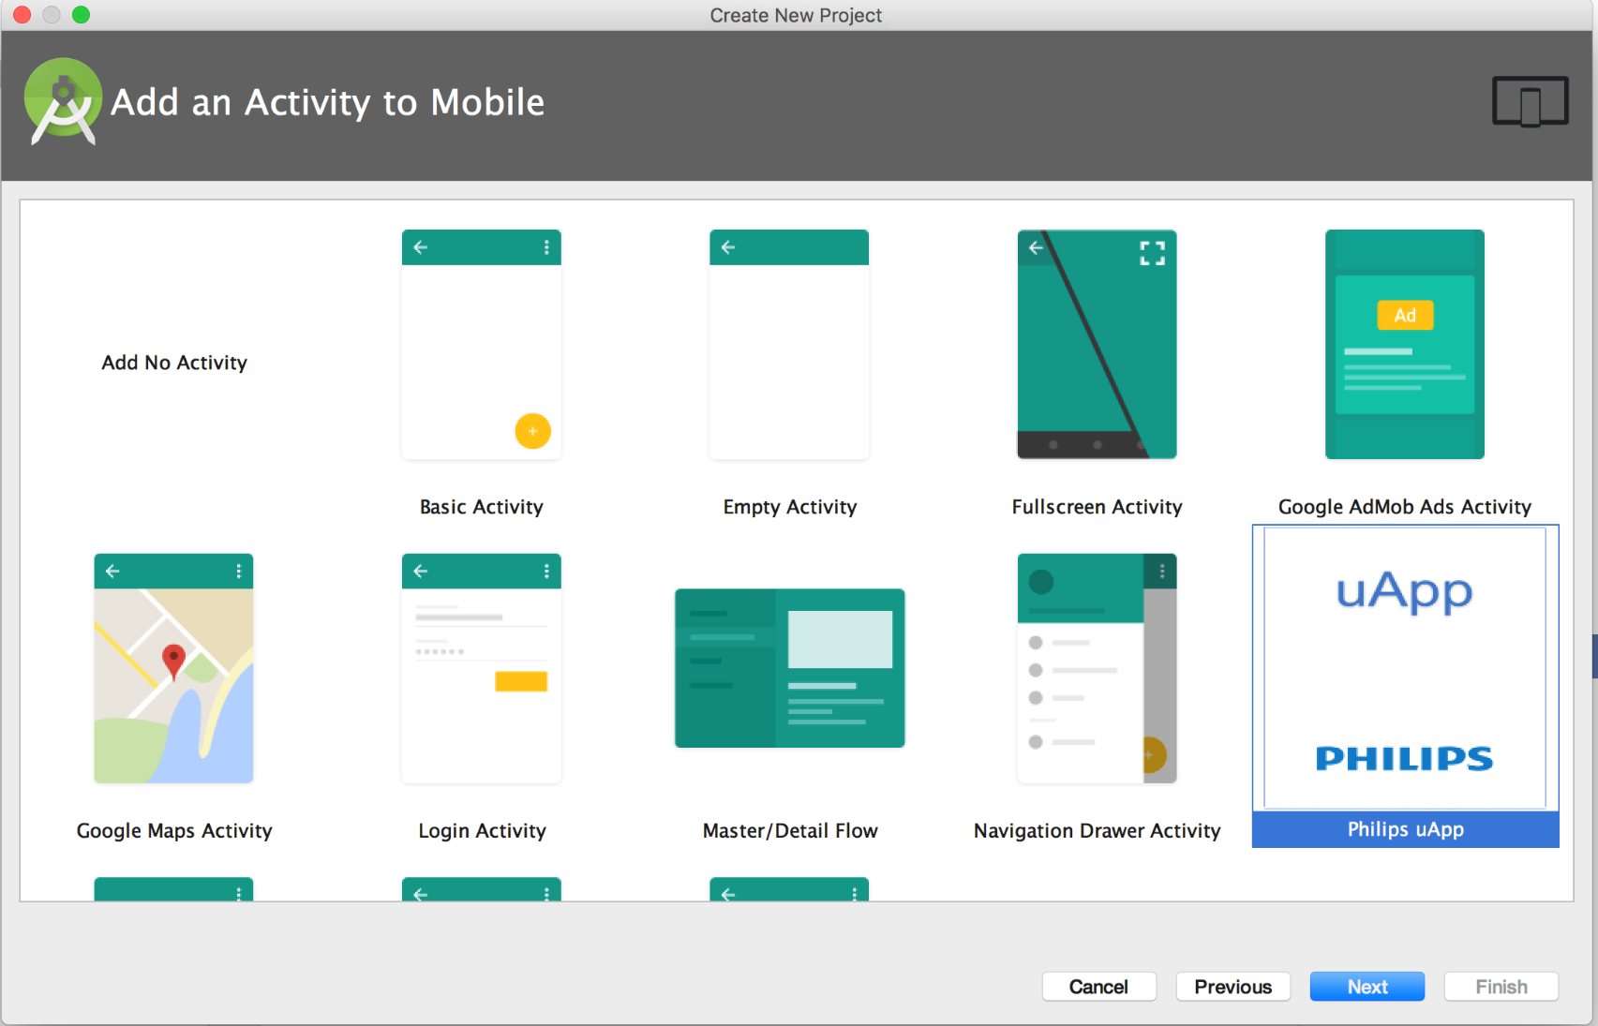

1. Provide Activity name as shown below and tapping finish will create Micro-app as per uApp defined standards.

